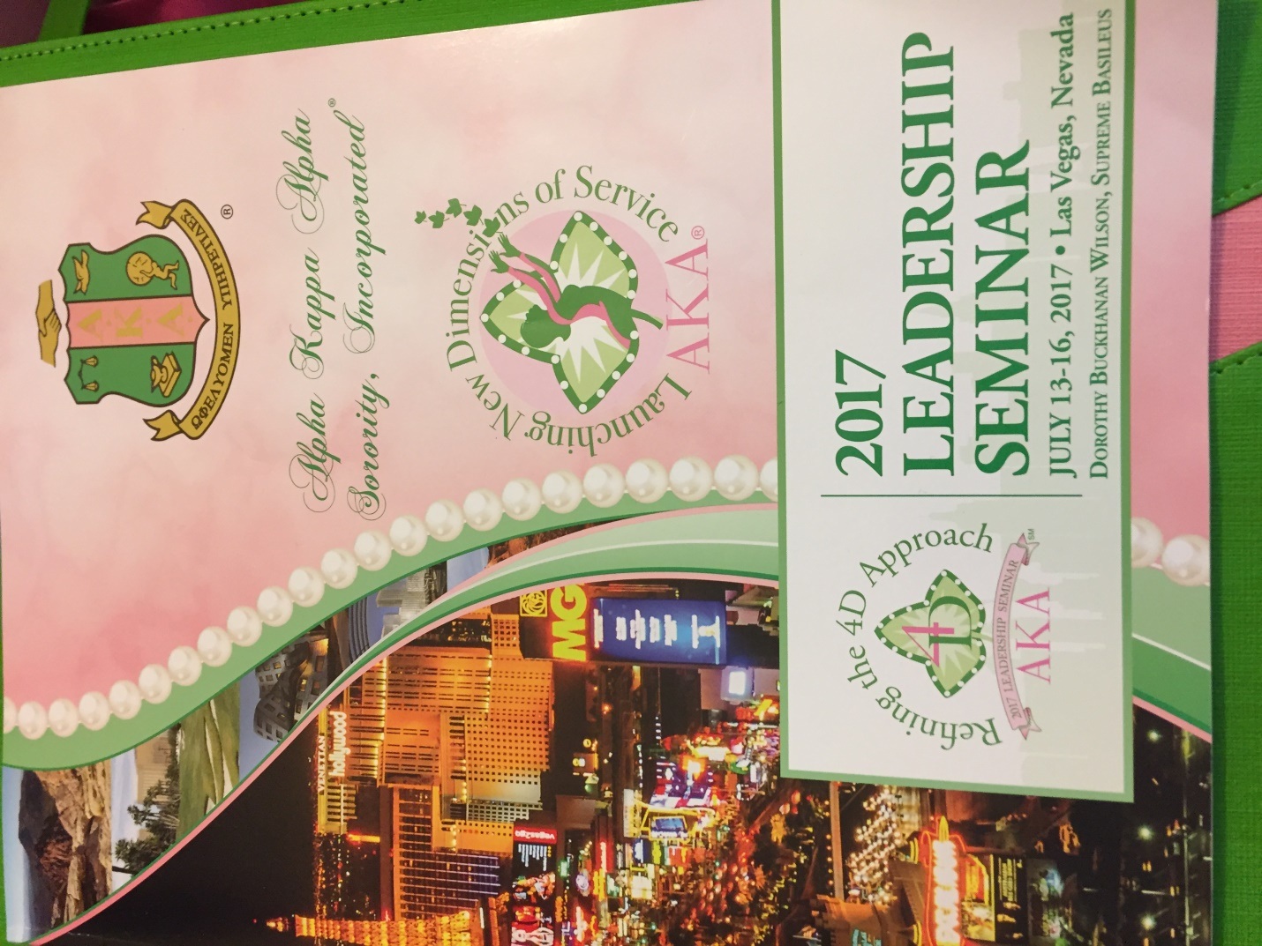

Launching New Dimensions of ACTION

Establishing Alpha Kappa Alpha Social Justice Agenda

Panlist: Soror Kim Greene

*Alpha Kappa Alpha Sorority, Inc.*

**INTERNATIONAL CONNECTION COMMITTEE FOCUS Refining The 4D Approach**

”The 2016 US presidential election is over. Now what do we do? Soror Sylvia Blackmon Roberts, International Connection Committee Chairman invited me to serve as a panelist for ’Be The Voice’ forum on social justice to discuss our organization plan for continued A.C.T.I.O.N. The stage was shared with the International Connection Committee, a distinguished panel of political leader and Actor, Radio Host, Stand-Up Comedian and Political Commentator Mr. D.L. Hughley.

The forum was moderated by Soror Sylvia Blackmon-Roberts, International Connection Committee Chairman. Madame Supreme, Dorothy Buckhanan Wilson shared introductory comments to welcome and to thank the AKA Connection International Committee, panelist and Mr. Hughley on their collective focus to Take ACTION as we face challenges in our communities and utilization of resources to craft advocacy in our communities. The welcome was given by Soror Twyla Woods Buford, Mid-Western Representative to the International Connection Committee and the introduction of the Keynote Speaker was given by Soror Tiffany Moore Russell Clerk of Court Orange County/Orlando, Florida and South Atlantic Regional Representative to the International Connection Committee.

Mr. D.L. Hughley mesmerized the audience of 2,000 sorors with his comedic personality. He then shifted to address, for approximately 20 minutes, national issues such as Education, Crime & Incarceration rates and Healthcare.

Drawing from varied experiences panelist responded to the question of issues impacting their areas. It was interesting to hear similarities such as Education, Crime and Incarceration rates, Healthcare and Immigration. As the state of South Carolina State Connection Chairman I introduced the issue of gentrification. Other panelist were Soror Kendra Brown, J.D., North Atlantic Region, Deputy Chief of Staff and Legislative Director for Congressman Dwight Evans, 2nd District, Pennsylvania and Soror Maureen Stapleton, President/Founder Community Enterprises, LLC, Great Lakes Representative International Connection Committee, Former Michigan State Representative.

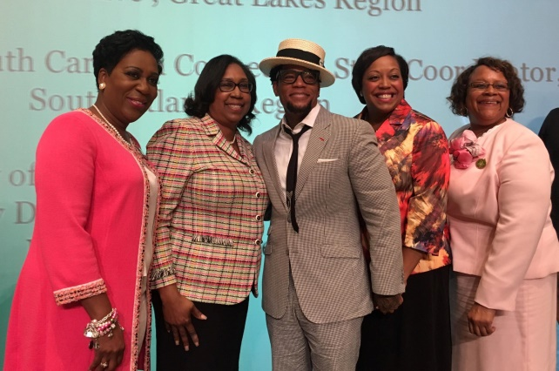 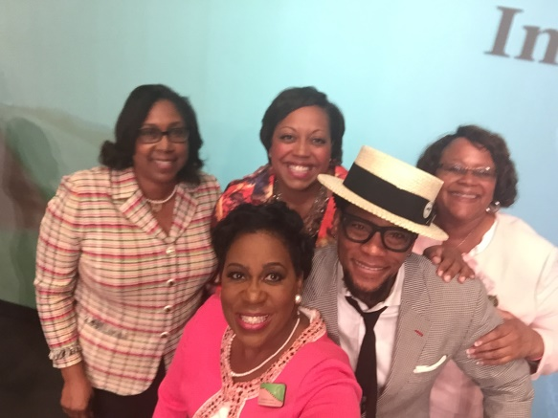

Forum take away included initiatives to prepare chapters and sorority members to shape the Black Agenda for local communities to and to use available resources to ensure chapter members become proactive advocates regarding social justice issues impacting the areas we serve.

*Following are a few snaps shots at 2017 AKA Leadership, Las Vegas, Nevada*

*\*\*\*\*\*\*\*\*\*\**

#Ivies On Top~500 Feet Above Las Vegas

 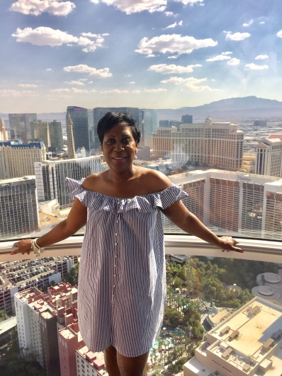 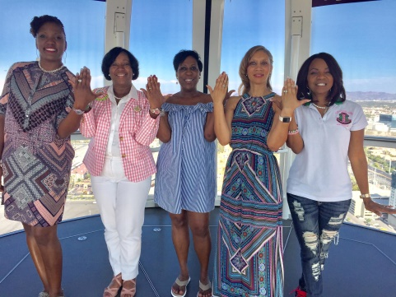

Soror Victoria Simpson, Undergraduate Member at Large & Gamma Xi Omega Members

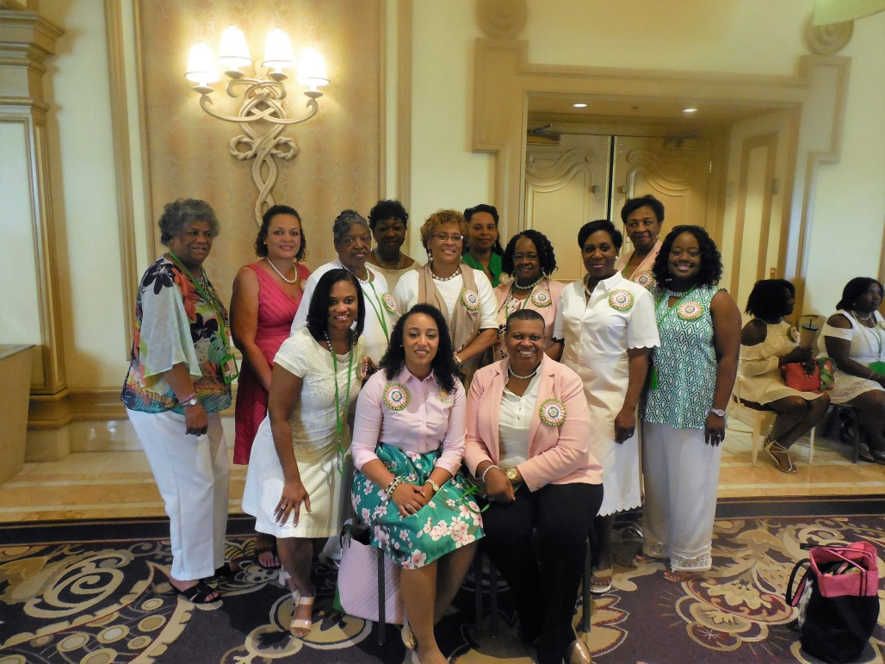

MRD Sharon Brown Harriott & SAR Cluster Coordinator Council

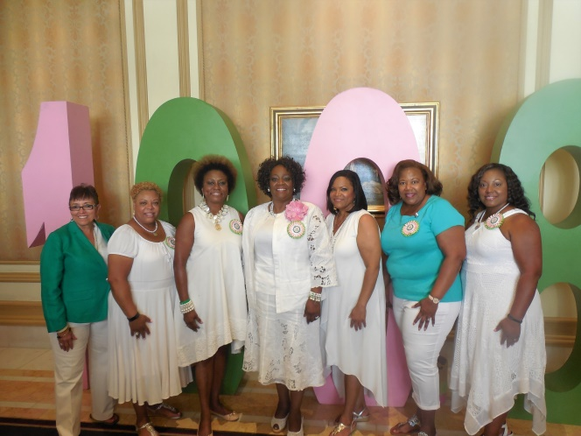

Love My Florida & Georgia Sorors

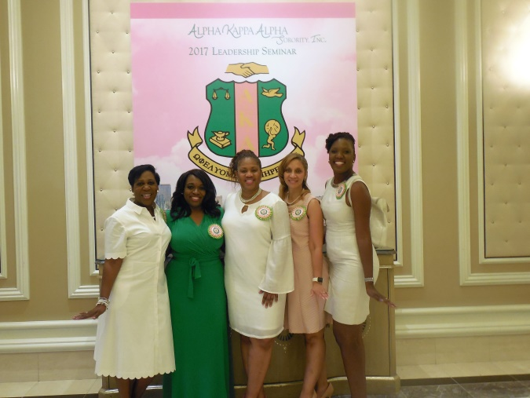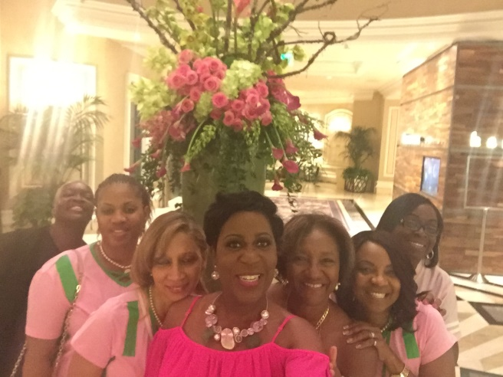

**Water Color Change 1st time Closing Gala~ Will Downing**

 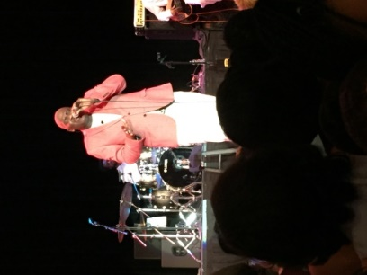

***Thank you for the opportunity to serve.*** 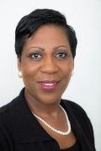

***Sisterly, Kimberly E. Greene***